**Dr. Elizabeth Hughes**

**Primary Supervisor:** Dr. Edward Wallace

**Secondary Supervisor:** Dr. Elizabeth Bayne

**Host Organization:** Institute for Cell Biology, School of Biological Sciences, University of Edinburgh.

**Project Title:**  Dynamic mRNA processing in response to environmental stimuli in the fungal pathogen *Cryptococcus neoformans*.

1. **Reasons for applying for a fellowship**

I am a skilled and highly motivated molecular biologist with 10 years lab-based experience, 6 post-doctoral. In order to succeed in the current job market, I need to update my skillset and access the rapidly advancing technologies and evolving practices in my field.

My PhD investigated the relationship of HIV viral populations and disease progression via evolutionary analysis of isolates infecting lymphoid and non-lymphoid tissues 1,2. My first author paper reported the discovery of a previously unknown dormant HIV population in the brain and has over 100 citations to date. 1 As a post-doc, I examined Hepatitis C Virus replicative processes by investigating a non-structural protein (NS5B) implicated in RNA-dependent-RNA-polymerase activity. I optimized bacterial expression systems and purified this protein. I also investigated the structure/function of the major- outer-membrane-proteins of *Chlamydia trachomatis* and *psittaci* where I cloned and expressed wild-type and mutated proteins and functionally reconstituted them at the single-channel level.3 I then joined a leading bio-safety testing facility, BioReliance, as the research and development scientist and developed a wide range of molecular based assays for clients while also providing technical training/support for colleagues.

I took a career break to raise my family. My husband works in the marine industry as a consultant which regularly takes him away from home for extended periods of time. Due to this and prohibitive childcare costs we decided I would put my career on hold and take on the administrative side of my husband’s business.

Both of my children now attend high school and I feel it is the right time for me to return to my chosen career. At 16 and 13 years they are mature and resilient enough to be at home without supervision for short periods of time. My family support my need to re-engage with the scientific community and my desire to re-start my career.

After applying for numerous positions, without success, I learned of the Daphne Jackson career re-entry Fellowship from my supervisor Dr. Wallace. This is an ideal platform for me to resume my biomedical research career because the emphasis is on improving employability through updating existing, and gaining new skills. This fellowship is exactly what I need to become competitive in the highly skilled and fast moving molecular biology field while still being able to care for my family. I aim to update my current skills while gaining expertise in new technologies, such as RNA-seq, which did not exist when I started my career break but is now routine, and forging relationships with prospective employers and mentors to ensure the success of my career.

Word count: 427/400

1. **How can an environmental fungus, *C. neoformans*, cause disease in a human?**

*Cryptococcus neoformans* is a fungus that lives in the environment growing on trees, pigeon droppings and in the soil. It infects people when they breathe it into their lungs. Infection is rare in healthy people and most cases occur in people with a weakened immune system. For example, cancer treatment patients or someone with HIV. In the lung it causes a pneumonia-like illness but it can also spread to the brain causing life-threatening meningitis. Approximately 1 million cases occur each year globally resulting in estimated deaths as high as 600,000.

**Aim 1**: How does the rapid change in environment from soil/vegetation to a mammalian lung affect how *C. neoformans* develops? I will examine what changes occur in this fungus when it reactivates in a warm, nutrient rich environment. Identifying critical processes in micro-organisms provides valuable knowledge for drug design.

**Aim 2**: Once *C. neoformans* has entered the lung it will encounter a number of foreign bodies, some of which will be bacteria that naturally live in us and others that may cause disease. I will investigate how this fungus interacts with these bacteria to examine how these interactions modify infection with *C. neoformans*.

**Aim 3**: Our lungs are covered in a mucus lining which helps protect us from infection from things we breathe in. This mucus has special proteins in it. One is called surfactant protein-D (SP-D) and this protein can kill micro-organisms and help our bodies fight them off. I will look at how this molecule attaches to *C. neoformans* to determine what changes occur in the fungus. Identifying unique pathways *Cryptococcus* uses to cause disease will provide unique targets for drug design.

I will look at the changes in the amount and type of genes that the fungus switches on and off during exposure to these conditions. Measuring the step between genes and proteins effectively bridges the gap between the genetic code and functional proteins, providing information on the amount of gene activity, which can tell us a lot about how an organism responds to its environment.

Fungal infections are one of the hardest diseases to manage in humans. Most infect people with underlying problems and jeopardize medical advances in cancer care and organ transplant because the immune system is weakened in these cases. With 600,000 deaths caused by *C. neoformans* infections world wide a concerted effort is needed to work out how this organism can change to grow in our lungs and spread through our bodies, avoiding all our defenses, to cause disease.

Word count: 416/400

**3. Abstract**

*C. neoformans* is an accidental pathogen of mammals. Its natural life-cycle occurs in the environment living on dead or decaying organic matter. The mammalian lung is an alien environment, yet somehow this fungus can circumvent a myriad of defenses to cause disease. Upon inhalation into a host lung, Cryptococcus cells transition from spores/desiccated yeast into actively replicating virulent yeast cells. This transformation must be associated with dynamic regulation of mRNA and hence gene expression. What happens to Cryptococci when they reactivate within a mammalian lung? This process will be investigated using simple laboratory models of early stages of infection to analyze differential gene expression of Cryptococcus under different environmental stimuli. Using *in vitro* culture methods to mimic the lung environment provides a method to dissect stimuli efficiently without the complications of, and need for, expensive animal models. Gene expression profiles represent a snapshot of cellular metabolism at the molecular level and may provide insights into novel therapeutic methods for drug discovery.

Word Count: 161/150

1. **Host Organization**

The University of Edinburgh is one of the world’s top universities, ranked 18th in the world, 4th in the UK and the top university in Scotland. As one of the UK’s leading research facilities it provides a state-of-the-art environment for research. This was reaffirmed by the results of the 2014 Research Excellence Framework placing this University as Scotland’s top-ranked research institution. The results revealed that 83% of research carried out was in the highest categories, 4* (world leading) and 3*(internationally excellent). The University of Edinburgh is a member of the SWAN charter and won its first Athena Swan Institutional Bronze Award in 2006 and has just renewed its Silver Award in 2018. The University of Edinburgh has also signed the national Concordat to support the career development of researchers. This document lays out 7 principles to increase the sustainability of research careers in the UK and to improve the quality, quantity and impact of research in society.

The Centre for Synthetic and Systems Biology, in the Institute for Cell Biology, is a unique inter-disciplinary environment with a track record for multi-disciplinary research. I will be joining the Wallace lab in this centre. Dr. Wallace is a new principal investigator at the University of Edinburgh, having established his lab in early 2018, consisting of Dr. Rosey Bayne (PDRA/Lab manager), Dr. Laura Tuck (PDRA) and Samuel Haynes (PhD student). The centre includes the Edinburgh Genome Foundry (a world class facility for automated DNA design and assembly) and EdinOmics providing expertise in quantitative biochemistry including up-scaling and automation of RT-qPCR. There are facilities for cell imaging (LEAP and single cell analysis and microscopy groups) and for innovative data analysis and mechanistic modelling.

My primary supervisor, Dr. Wallace, is a quantitative biologist specializing in fungal RNA processing. Working with him will allow me to build on my existing skills in the field of molecular biology whilst learning new techniques including medium throughput RT-qPCR, cDNA library preparation and high throughput sequencing (RNA-seq), lab automation, bioinformatics, and working with large data sets. This will provide me with crucial work experience in one of Scotland’s world-class universities and equip me with specific skills in high demand in biomedical research and biotechnology industries.

My collaborator, Dr. Ballou, is an expert in *C. neoformans* biology, including relevant culture conditions and models of host-pathogen interaction required for this proposal. Dr. Ballou will contribute advice and training as well as support professional development.

Dr. Bayne has 30 years of experience in molecular biology techniques and will take a lead role in my technical/lab based training.

Table 1: Supervisors and Collaborators

|  |  |  |  |
| --- | --- | --- | --- |
|  | Name | Institute | Position |
| Primary Supervisor | Dr. Edward Wallace | The University of Edinburgh | Sir Henry Dale Fellow (Wellcome Trust/Royal Society Early Career Research Fellow).  Institute for Cell Biology, School of Biological Sciences |
| Secondary Supervisor | Dr. Elizabeth Bayne | The University of Edinburgh | Reader in Epigenetics, School of Biological Sciences, |
| Collaborators | Dr. Elizabeth Ballou | University of Birmingham | Sir Henry Dale Fellow and Lecturer.  Institute for Microbiology and Infection, School of Biosciences |

Word Count: 424/400**5. Retraining Program**

**5.1: Technical Skills**

In order to carry out the proposed aims of my fellowship application I will have to learn a number of new skills while updating existing ones. I will vastly expand my knowledge of new exciting techniques like RNA-seq while updating existing ones such as qPCR. Learning large scale data set production and analysis will be vital for this project due to the large volume of data that will be produced. The ability to handle and analyze large data sets is becoming an imperative skill in modern biomedical science.

Table 2a: New and Refreshed Technical Skills

|  |  |  |
| --- | --- | --- |
| Training |  |  |
| New Skills | Method | Trainor/Course |
| How to culture and extract RNA from Cryptococcus | 1-1 | Dr. Bayne/Dr. Ballou |
| How to identify and phenotype Cryptococcus using various microscopic techniques and stains | Course/1-1 | The Wellcome Centre Microscopy Course run by Dr. Kelly at the University of Edinburgh/Dr. Ballou |
| Lab automation to enable processing of large numbers of RT-qPCR | 1-1 | 1-1 at the Edinburgh Genome Foundry in the University of Edinburgh |
| Bio-Informatics to analyze the large data sets produced | Course/1-1 | Bioinformatics for Genomics, a 5 day workshop run at the Edinburgh Genomics Centre in the University of Edinburgh (£750)/Dr. Wallace |
| Refreshed Skills |  |  |
| Aseptic technique | 1-1 | Dr. Bayne |
| RNA manipulation | 1-1 | Dr. Bayne |
| RT-qPCR | 1-1 | Dr. Bayne and Dr. Wallace |
| Learn how to use updated tools/equipment for these methods | 1-1 | Dr. Bayne and Dr. Wallace |

This fellowship will increase my employability by bridging my skills gap using a framework for structured training of relevant skills in demand in today’s job market. I will train under the guidance of Dr. Wallace, Dr. Ballou and Dr. Bayne who are proficient in all the necessary techniques and are committed to supporting me and my endeavor to return to the workforce. My training will build on my current skills to update my expertise while developing new in-demand skills and forging new relationships in a work environment.

**5.2: Professional Skills/Development**

During this fellowship I will have access to 3 training courses from the Daphne Jackson Trust covering professional skills, how to publish and how to improve your confidence. This provides an excellent opportunity for me to develop as a researcher and also as a person. Having been away from science for a number of years, building confidence in myself and my ability is very important.

The Institute for Academic Development at the University of Edinburgh is a facility providing many opportunities for education and professional development. The available program provides workshops and courses on academic writing, career management and development, data management, funding opportunities, ethics, teaching and supervising students. During my fellowship I will use these resources to enhance my professional qualifications/development. Within the Institute for Cell Biology there is also a dynamic seminar series covering a wide range of topics from internal and external speakers.

Table 2b: Personal development opportunities

|  |  |  |
| --- | --- | --- |
| Course | Method | Provider |
| Professional skills | Workshop | Daphne Jackson Trust |
| How to publish | Workshop | Daphne Jackson Trust |
| How to improve your confidence | Workshop | Daphne Jackson Trust |
| Finding funding for research | Online | IAD* |
| Get that paper written and published | Workshop | IAD* |
| Managing your research data | Workshop | IAD* |
| Writing research proposals for the college of science and engineering | Workshop | IAD* |
| Attracting your own research funding | Workshop | IAD* |
| Be better than boring bullet points: giving a great presentation | Workshop | IAD* |
| Academic CVs | Workshop | IAD* |
| Effective collaborations | Workshop | IAD* |
| Practical project management for researchers | Workshop | IAD* |
| Professional networking, engaging and strategy | Workshop | IAD* |
| Project management (research) | Workshop | IAD* |
| Spotlight on…Co-supervision | Workshop | IAD* |
| Time management | Workshop | IAD* |

*The Institute for Academic Development at the University of Edinburgh

During my training I would also like to attend relevant conferences as these provide a national/international platform for sharing information and ideas and keeping up to date with the latest innovations and advancements. Some upcoming conferences within the field of mycology are:

* British Society for Medical Mycology, March 2019, Sheffield (Annual).
* Human Fungal Pathogens, May 2019, France (Biennial).
* 6th International Conference on Mycology and Fungal Infections, Oct 2019, UAE.
* 11th International Conference on Cryptococcus and Cryptococcosis, 2020, Uganda.
* International Society for Human and Animal Mycology, March 2021, India.

Word Count: 415/400

Table 2c: Re-Training Program Summary

|  |  |  |  |  |  |  |
| --- | --- | --- | --- | --- | --- | --- |
| Skill | Methods | Refresh  skills | New  skills | Month | Base* | Objective |
| Cell Culture Techniques | Culture preparation/storage | ✓ | ✓ | 1-3 | LB | Refresh knowledge and apply to fungal cells to test the effect different environmental stimuli have on the morphology of Cryptococcal cells, correlate with gene expression. |
| Sub culturing/cell-maintenance | ✓ | ✓ |
| Aseptic technique | ✓ | ✓ |
| Microscopic Techniques | Visualization/fixing/staining of fungal cells | ✓ | ✓ | 1-3 | LB | Identify morphological changes in cultured yeast cells grown in the presence of different environmental stimuli. |
| RNA Manipulation | QIAgen plant and fungal RNA extraction kit |  | ✓ | 3-6 | LB | Gain experience in using up-to-date techniques for the isolation of RNA from fungal cells. |
| Assess RNA quality/quantity, Agilent bioanalyzer | ✓ | ✓ |
| RT-qPCR | Primer design/validation | ✓ |  | 3-8 | LB | SYBR-Green fluorescence based qPCR to analyse gene expression in response to environmental stimuli to provide a deeper understanding of the molecular mechanisms underpinning physiological change. |
| RT-qPCR | ✓ |  |
| cDNA synthesis | ✓ |  |
| Data analysis |  | ✓ | 9-14 | CB |
| Lab Automation | RT-qPCR using 384/1536-well plates |  | ✓ | 3-8 | LB | Training in automatic plate loading at Edinburgh Genome Foundry |
| Next Generation  Sequencing | RNA-seq |  | ✓ | 13-19 | LB | Illumina sequencing with random primed cDNA synthesis non-strand specific protocol to quantify the dynamic expression levels in yeast cells under variable conditions. This technique enables novel RNA's to be discovered. |
| Data analysis |  | ✓ | 16-21 | CB |
| Bio-Informatics | R-Programming |  | ✓ | 1-24 | CB | Use R to analyse RT-qPCR and DESeq2 to analyse RNA-seq data. As required additional analytical methods will be employed. |
| Handling/analysis of large data sets |  | ✓ | Continuous | CB |
| Personal Development | Attend courses on scientific writing, bioinformatics,  writing for grants/proposals, oral presentations,  networking and leadership | ✓ | ✓ | Continuous | TBD | Gain valuable transferrable skills for further development of my career and to secure further funding or employment following this fellowship. |
| Attend Seminars/  Conferences | Expand knowledge base | ✓ | ✓ | Continuous | TBD | Network with other scientists to share my research/initiate future possible collaborations. |
| Meetings with Sponsor | Discuss research project and progress |  | ✓ | Bi-annual | OB | Discuss progression of project and training enabling me to keep on track.  Implement new training strategies where applicable. |
| Progression Milestones | Reports/publications | ✓ | ✓ | Annual | OB | Provide yearly reports on progression of project and publish results in peer reviewed journals. |

*LB-Lab based, OB- Office Based, CB- Computer based, TBD-To be decided

1. **Dynamic mRNA processing in response to environmental stimuli in the fungal pathogen *Cryptococcus neoformans*.**

**Background:**

*C. neoformans* is an opportunistic facultative saprophyte and the causative agent of cryptococcosis. 4,5. *C. neoformans* primarily infects immunocompromised individuals and is one of only a few fungal species that have been shown to cross the blood-brain barrier leading to cryptococcal meningitis that is fatal if left untreated 4,5. The onset of the AIDS epidemic in the 1980’s was accompanied by a surge in cryptococcosis cases world-wide. Antiretroviral therapy and antifungals have reduced the number of fatal cryptococcal meningitis cases, however, it remains a serious concern for the immunocompromised and is a major problem in resource-limited countries, where HIV prevalence is high, and access to health care and appropriate drug regime’s is limited. A global number of almost 1 million cases of cryptococcal meningitis are estimated to occur with an estimated 600,000 resulting deaths.4,6 Cryptococcus is prevalent in the environment world-wide with over 70% of cases occur in sub-Saharan Africa. However, an outbreak of *Cryptococcus gatti* in immunocompetent individuals has been reported in North America7–9.

*C. neoformans* is found in the environment typically associated with pigeon guano, soil and decaying wood. It is a free living fungus with no requirement for a mammalian host, however, it is able to adapt, survive and proliferate within a mammals to cause disease. Inhalation of the basidiospore and/or desiccated/weakly encapsulated yeast cells are postulated to act as infectious propagules as only particles smaller than 5µm in diameter can reach the alveoli. The natural ecology and long-term disease progression of *C. neoformans* is beginning to be characterized, however, there is even less understanding of the early stages of *C. neoformans* infection. *C. neoformans* must undergo rapid changes in gene expression to adapt to the alien environment of the lung. Indeed not many fungi can grow at the human body temperature of 37⁰C, a characteristic virulence factor of *C. neoformans* and consistent with its role as a human pathogen10.

Gene expression profiling enables investigation of the effects of different environmental conditions by altering the environment to which the organism is exposed. Knowing an organism is expressing certain genes provides information about how the organism functions and potentially new insights into which genes (and therefore proteins) are involved in certain behaviors, and may elucidate the important steps for infection at early time-points. For example, modification of cell wall composition/structure will likely play a crucial step in the initial infection and establishment of *C. neoformans* in a mammalian host.

I will examine in detail what happens when this organism reactivates within this alien environment and elucidate the adaptive response/responses required for this accidental pathogen to survive.

**Aim 1: What environmental stimuli in the host trigger an acute stress response in *C. neoformans*?**

Current knowledge of the early events in *C. neoformans* infection are based on research using animal models or *in vitro* culture methods, primarily in rich fungal support media such as YPD during log phase growth. While these methods have produced useful data they do not accurately reflect the deposition of desiccated yeast into the lung environment, where nutrients are likely to be scarce.

Previous investigations carried out by Dr. Wallace, in collaboration with Dr. Ballou, were designed to dissect the contributions of host factors and temperature in shaping initial growth. In this pilot study a distinct physiological response (capsule induction) and differential RNA abundance were documented between the different conditions (see Fig. 1-4). Different capsule phenotypes have been observed in different organs and *C. neoformans* can modify the size and structure of its capsule in response to environmental stimuli suggesting plasticity of the capsule is of biological importance.

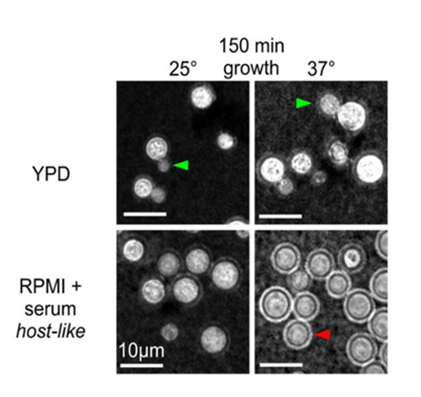

Fig 2: Micrograph with India ink staining 150 min after inoculation. Budding (green arrow) in YPD. Capsule induction (red arrow) in RPMI at 37⁰C

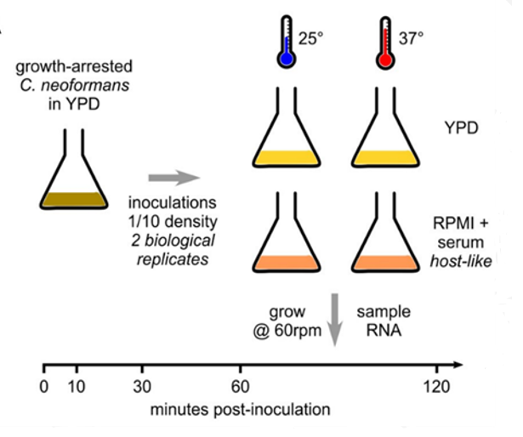

Fig 1: RNA time course to measure the contribution of nutrient and temperature to initial growth.

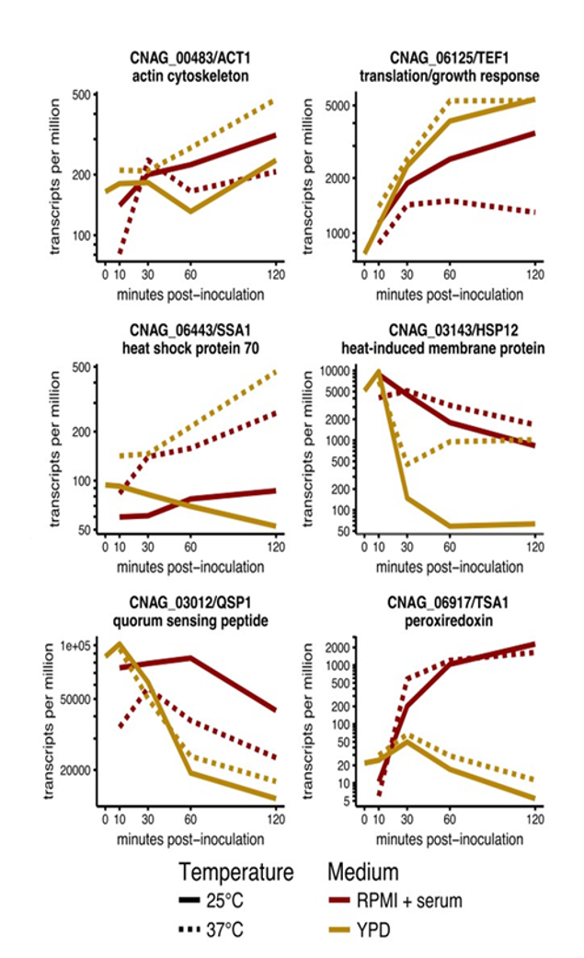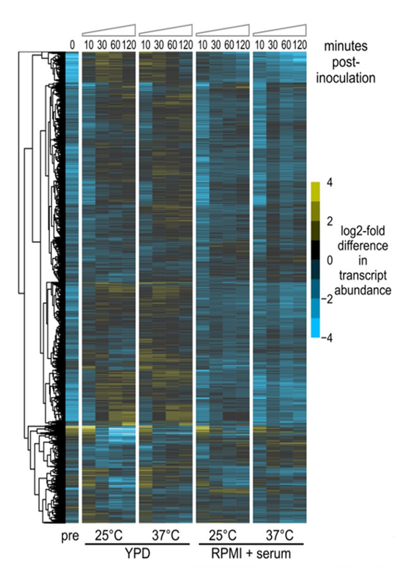

Fig 3: Heat map shows log2 of the difference from median abundance (transcripts/million) for each RNA, log2 mean of 2 biological replicates.

Fig 4: Select genes showing differential regulation of RNA abundance (transcripts/million), log2 mean of 2 biological replicates.

**Objective:**

In the first 3 months I will retrain in cell culture and microscopy techniques and apply this to growing and identifying yeast cell morphologies. In months 3-6 I will learn how to extract RNA from yeast cells using the QIAgen-plant-and-fungal-RNA-extraction-kit and will identify what causes this phenotypic shift by analyzing differential gene expression using RT-qPCR. I will also be trained in lab automation at the genome foundry to enable me to upscale the RT-qPCR through automatically loaded plates of 1536 wells. This will highlight the important steps for infection and will provide me with an opportunity to further develop my molecular and microbiology skillsets. I will be trained how to use R to analyze large data sets produced in the second half of my first year.

**Method:**

I will inoculate growth-arrested *C. neoformans* yeast cells grown in YPD (GA-Cn-YPD) into RPMI-1640 media and YPD + serum and incubate at 25⁰C and 37⁰C and 5% CO2. I will determine any phenotypic changes (India ink stain for capsule induction) and extract RNA for analysis using RT-qPCR (verified primers against differentially expressed genes previously detected by RNA-seq in the Wallace lab). I will compare alterations in the gene profile in relation to phenotype.

Analysis of this data will determine future studies. If the addition of serum, a key host-relevant stimulus, is sufficient for capsule induction I will incubate GA-Cn-YPD in RPMI-1640 + purified albumin and RPMI-1640 + charcoal stripped FBS (CS-FBS). This will further dissect which component of serum is responsible for capsule induction by comparing the effect of albumin and reduced levels of endotoxins and hormones (reduced in CS-FBS). (See table 3a below).

Table 3a: Dissection of serum components

|  |  |  |  |  |  |  |
| --- | --- | --- | --- | --- | --- | --- |
| Media | No Serum (Serum starvation) | FBS | Charcoal stripped FBS | Albumin | 25⁰C | 37⁰C |
| RPMI-1640 | ✓ |  |  |  | ✓ | ✓ |
|  | ✓ |  |  | ✓ | ✓ |
|  |  | ✓ |  | TBD | ✓ |
|  |  |  | ✓ | TBD | ✓ |
| YPD | ✓ |  |  |  | ✓ | ✓ |
|  | ✓ |  |  | ✓ | ✓ |
|  |  | TBD |  | TBD | TBD |
|  |  |  | TBD | TBD | TBD |

However, if the addition of serum does not induce capsule in YPD media I will dissect the components of RPMI-1640 media to elucidate which component is responsible for this phenotypic change. RPMI-1640 has very low concentrations of Mg2+ and Ca2+ and elevated levels of PO42- and glucose compared to human serum and CSF11. Increased concentrations of Mg2+ have been shown to act as a possible signal for capsule production12 and phosphate acquisition has been shown to be important for virulence in *C. neoformans*13. A recent study comparing the physiological relevance of culture media concluded that the most commonly used culture media did not provide an environment with physiological electrolyte or carbohydrate concentrations11. Of those examined, Minimum Essential Media (MEM) contained electrolyte and carbohydrate levels close to that in human serum and CSF. I will incubate GA-Cn-YPD in MEM at 25⁰C and 37⁰C and determine any phenotypic changes in capsule induction (India ink stain). RPMI-1640 routinely contains phenol red (pH indicator) which is a weak oestrogen14 and such steroids have been shown to inhibit *C. neoformans* growth15 and have shown a synergistic/additive *in vitro* activity with drugs currently used to treat cryptococcosis 16,17 I will investigate the impact that removing phenol red from RPMI-1640 has on capsule induction.

Table 3b: Dissection of media components

|  |  |  |
| --- | --- | --- |
| Media | 25⁰C | 37⁰C |
| RPMI-1640 + phenol red | ✓ | ✓ |
| RPMI-1640- phenol red | TBD | ✓ |
| MEM | ✓ | ✓ |

**Aim 2**: **Investigate how bacterial cell wall components influence gene expression in *C. neoformans*.**

In many environments bacteria and fungi coexist and interact in nature competing for space and nutrients. Similar cross-species interactions are expected to occur between the wide range of micro-organisms that constitute the human microbiome18–20.The lungs of immunocompromised individuals are frequently colonized by bacteria and fungi21. Bacteria can stimulate spore germination in several fungi22–24 and it has been shown that germination of *C. neoformans* is essential for survival in phagolysosomes25. Cell wall fragments are increasingly recognized as important signaling molecules that can inhibit growth and virulence factors and influence morphology of microbes. The addition of fetal calf serum (FCS) to media induces capsule formation in *C. neoformans*26. The Ballou lab have shown that bacterial cell wall components modify the morphology of *C. neoformans* from a normal yeast cell to a large polyploid titan cell.27. The peptidoglycan subunit muramyl dipeptide, in purified form or as a component of serum, induces titan cells.

**Objective:**

I will examine the transcriptional response of *C. neoformans* to bacterial cell wall components. I will measure changes in gene expression and relate these, using microscopy, to key phenotypes to identify molecular mechanisms underlying these changes. I will extract RNA for analysis using RT-qPCR and RNA-seq to identify unknown enriched genes or pathways. This will involve training in RNA-seq (month13-19) and bioinformatics for data analysis using DESeq2 (months 1-24).

**Method:**

I will identify interactions between the fungal cell surface and bacterial cell wall components by incubating GA-Cn-YPD (fast growing) and GA-Cn-YPD (starved) yeast cells in serum-free media (RPMI-1640 and/or MEM depending on results from Aim 1) with different concentrations of purified components of bacterial cell walls:

* Peptidoglycan subunits found in gram positive and gram negative bacteria:
  + - N-acetyl glucosamine (NAG)
    - N-acetyl muramic acid (NAM)
    - Muramyl dipeptide (MdP)
* Lipopolysaccharide (LPS) found in gram negative bacteria and
* Teichoic Acid (TA) found in gram positive bacteria.

These reagents are all commercially available. I will incubate cells at 25⁰C and 37⁰C if capsule was induced at both temperatures in aim 1. Otherwise, I will only carry out these experiments at 37⁰C. Depending on results from pilot studies I will further characterize the effect of lipopolysaccharide by incubating yeast cells with the subunits lipid-A (antigenic), core polysaccharide and/or o-polysaccharide.

Table 4: Experimental plan-Aim 2.

|  |  |  |  |  |  |
| --- | --- | --- | --- | --- | --- |
| RPMI-1640 and/or MEM | Supplemented with 0-20µg of | GA-Cn-YPD (fast growing) | | GA-Cn-YND (starved) | |
| 25⁰C | 37⁰C | 25⁰C | 37⁰C |
|  | NAG | TBD | ✓ | TBD | ✓ |
| NAM | TBD | ✓ | TBD | ✓ |
| MdP | TBD | ✓ | TBD | ✓ |
| LPS | TBD | ✓ | TBD | ✓ |
| TA | TBD | ✓ | TBD | ✓ |

**Aim 3**: **Investigate how surfactant protein D (SP-D) influences gene expression in *C. neoformans*.**

Infection with *C. neoformans* is initiated in the lung and the pulmonary innate immune system is the first line of defense in the host. Collectins in the alveolar lining fluid are part of this local innate immune response. They are secreted proteins that can interact with pathogens through their carbohydrate recognition domain (CRD) and modulate immune effector cells and host cytokine responses. These include the lung surfactant proteins A and D, and mannose binding lectins (SP-A, SP-D and MBL’s), which have all previously been shown to bind to *C. neoformans* 28–32. *In vitro* studies suggest SP-A can bind acapsular/capsular yeast cells but with a far reduced affinity compared to SP-D. *C. neoformans* was shown to be resistant to SP-A binding once capsule synthesis had been induced33. In contrast, SP-D binds acapsular yeast with a high affinity (and capsular yeast with a lower affinity) causing profound aggregation, increased phagocytosis and enhanced fungal survival29,30,34,35. However, it is not known how *C. neoformans* responds to binding by SP-D.

**Objective:**

I will investigate how binding of SP-D affects *C. neoformans* by analyzing gene expression before and after binding of purified recombinant human SP-D (rh-SP-D). Direct binding of rh-SP-D may modulate gene expression in a synergistic or antagonistic way and could therefore reciprocally modulate virulence factors and enhance fungal survival. I will use RT-q-PCR and RNA-seq and will be proficient at both techniques and data analysis at this stage of my fellowship.

**Method:**

I will grow yeast cells in capsule-inducing and non-capsule-inducing conditions and incubate these in RPMI-1640 or MEM, depending on results from Aim 1, with serial dilutions of rh-SP-D (commercially available) at 25⁰C and 37⁰C in cell culture plates. I will examine the plates for agglutination ofyeast cells by light microscopy (see table 5). .I will extract RNA for further analysis using RT-qPCR and RNA-seq. Dependent on the results from these experiments I will decide whether or not to test binding of SP-A and MBL to yeast cells and analyze gene expression.

Table 5: Experimental plan-Aim3

|  |  |  |  |  |  |  |  |
| --- | --- | --- | --- | --- | --- | --- | --- |
| RPMI-1640 or MEM | rhSP-D (µg/ml) | Capsule inducing | | | Non-capsule inducing | | |
|  | | 25⁰C | 37⁰C | | 25⁰C | 37⁰C |
|  | 2 | | ✓ | ✓ | | ✓ | ✓ |
| 4 | | ✓ | ✓ | | ✓ | ✓ |
| 6 | | ✓ | ✓ | | ✓ | ✓ |
| 8 | | ✓ | ✓ | | ✓ | ✓ |
| 10 | | ✓ | ✓ | | ✓ | ✓ |

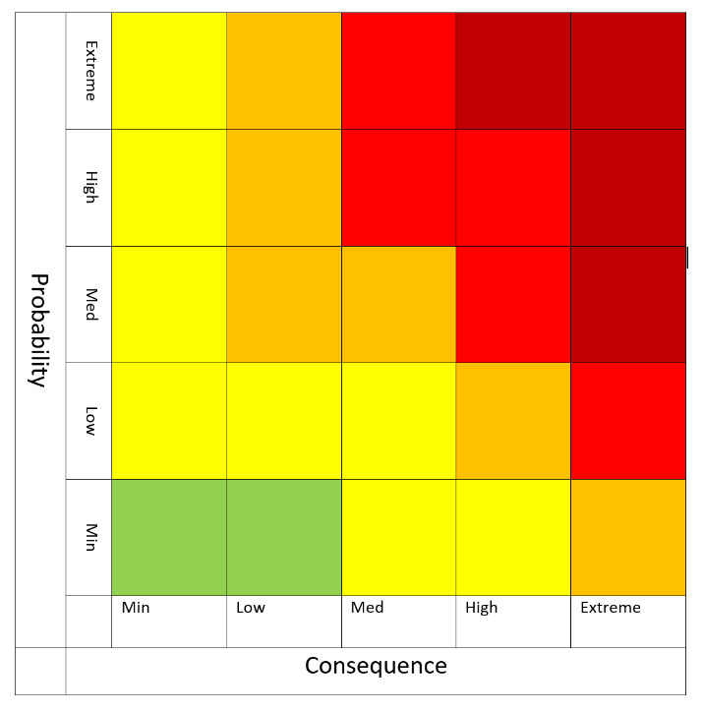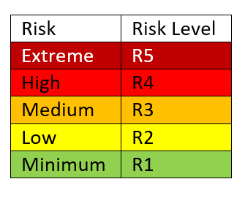Table 5a: Risk Assessment of procedures:

Table 5b: Mitigation summary

|  |  |  |  |  |
| --- | --- | --- | --- | --- |
| Process | Hazard | R-M* | Mitigation | R+M** |
| Handling of *C. neoformans* | Laboratory associated infection | R1 | * Category 2 pathogen * Biosafety level 1 * Standard microbiological practices * The Wallace lab has risk assessment in place, including biosafety and genetic modification | R1 |
| Cell culture | Contamination during inoculation, incubation and harvesting | R2 | * Use aseptic technique * Use sterile equipment * Use sterile flask stoppers * Use sterile reagents | R1 |
| Lyophilisation of cells | Contamination | R4 | * Carried out within a vacuum at -80⁰C * Use sterile equipment | R1 |
| Reagents used for RNA extraction | Contamination | R2 | * All reagents are part of a kit validated by the manufacturer * Use RNA handling techniques such as gloves and RNase free diluents and Eppendorf’s | R1 |
| Normalisation of RNA extraction | Inter- and intra-sample variation | R5 | * Spike in a 1:100 ratio of methanol-fixed *Schizosaccaromyces pombe,* using three reference genes. | R1 |
| Removal of genomic DNA from RNA samples | Contaminating genomic DNA | R3 | * DNase treat samples * Check quality using nanodrop ʎ260/280 ratio and agilent bioanalyser | R1 |
| cDNA Synthesis for RT-qPCR | Contamination with PCR artefacts | R3 | * Run 3 biological replicates * Determine whether the same sequences are observed in each * Use appropriate controls; no template and no RT enzyme | R1 |
| Primer design for RT-qPCR | Ensure specificity | R3 | * All the primers to be used have been developed and validated in the Wallace labs to show specificity | R1 |
| Reagents for RT-qPCR | Contamination | R3 | * All reagents are part of a kit validated by the manufacturer * Use RNA handling techniques such as gloves and RNase free diluents * Use RNase free Eppendorf’s * Use appropriate controls; no template | R1 |
| Normalisation of RT-qPCR for data analysis | Misrepresentation of expression profiles obtained | R3 | * Select 3-4 stably expressed reference controls * Use the mean to normalise differences in the amount and quality of starting material * Use the mean to normalise the efficiency of the reaction | R1 |
| Library construction for RNA-seq | Contamination with PCR artefacts | R3 | * Run 3 biological replicates * Determine whether the same sequences are observed in each * Use appropriate controls; no template and no RT enzyme | R1 |
| Training | Ineffective training | R4 | * See re-training program * Discuss progression of training with sponsor * Implement new training strategies where applicable | R1 |
| Equipment | Failures | R5 | * All equipment is maintained to a high standard within the Wallace labs by the lab manager | R1 |
| Timelines | Failure to complete the project | R5 | * Implement good time management and organisational strategy (see Timetable) * Review progress every 6 months with supervisor * Compile yearly reports | R1 |

*R-M: Risk without mitigation, **R+M: Risk with mitigation

From the risk assessment you can see that the key elements of mitigation are:

* Implementing good time management
* Organisational strategies
* 6 monthly and yearly reviews/reports
* Adherence to the proposed training schedule
* Good laboratory practice

These will ensure that this project is carried out to a high standard and will be completed within the timeframe given.

**Impact:**

This research is discovery driven and will advance knowledge regarding the initial stages of Cryptococcal infection in the lung. Functional profiling under differing stimuli may identify enriched pathways and/or micro-evolutionary adaptations during the early phase of *C. neoformans* infection and pave the way for the development of novel methods to abrogate the infection and dissemination of this fungus. I expect this fellowship to lead to 3 peer reviewed papers, 2 as first author. This research will be presented at conferences and seminars in order to engage the wider community and forge future collaborations.

**Further work:**

Further studies to elucidate the early stages of infection include examining the environmental impact of spores/desiccated yeast cells upon entry to the lung and comparing gene profiles with that of stationary phase yeast cells studied here. Investigation of how other micro-organisms in the lung contribute to Cryptococcal infection and propagation through bi-microbial cultures and investigation of the effects small signal peptides, produced by microbes,could provide important insights into novel pathways for the development of anti-fungal drugs. Finally, I would like to examine differential gene expression in titan and daughter cells to determine what differences occur and relate these to early the infection process. It is my intention to build on the experience I gain during this fellowship to develop a research strategy and collaborations that will follow on from this opportunity.

Word count: 2085/2250

**7. Ethical approval and licenses**

This work is covered by the School of Biological Sciences' ethics assessment ewallac2-0002, "Dynamic RNA processing in adapting fungi". The proposed work will be entirely with model fungi grown in liquid or solid media in laboratory conditions. No work will be conducted with patients, nor with animals, nor with animal/human tissue. There will be no contact with clinical data.

Cryptococcus neoformans is a category 2 pathogen and the Wallace lab has all risk assessments in place, including biosafety and genetic modification, for the proposed work.

**8. Timetables**

Table 6a: Training/Re-training

|  |  |  |  |  |  |  |  |  |  |  |  |  |  |  |  |  |  |  |  |  |  |  |  |  |
| --- | --- | --- | --- | --- | --- | --- | --- | --- | --- | --- | --- | --- | --- | --- | --- | --- | --- | --- | --- | --- | --- | --- | --- | --- |
| Task | Month | | | | | | | | | | | | | | | | | | | | | | | |
|  | 1 | 2 | 3 | 4 | 5 | 6 | 7 | 8 | 9 | 10 | 11 | 12 | 13 | 14 | 15 | 16 | 17 | 18 | 19 | 20 | 21 | 22 | 23 | 24 |
| Cell culture techniques for fungi |  |  |  |  |  |  |  |  |  |  |  |  |  |  |  |  |  |  |  |  |  |  |  |  |
| Microscopy |  |  |  |  |  |  |  |  |  |  |  |  |  |  |  |  |  |  |  |  |  |  |  |  |
| RNA extraction using updated methods |  |  |  |  |  |  |  |  |  |  |  |  |  |  |  |  |  |  |  |  |  |  |  |  |
| cDNA synthesis |  |  |  |  |  |  |  |  |  |  |  |  |  |  |  |  |  |  |  |  |  |  |  |  |
| RT-qPCR |  |  |  |  |  |  |  |  |  |  |  |  |  |  |  |  |  |  |  |  |  |  |  |  |
| Automatic plate loading 1536 wells |  |  |  |  |  |  |  |  |  |  |  |  |  |  |  |  |  |  |  |  |  |  |  |  |
| R Programming |  |  |  |  |  |  |  |  |  |  |  |  |  |  |  |  |  |  |  |  |  |  |  |  |
| Data analysis for RT-qPCR |  |  |  |  |  |  |  |  |  |  |  |  |  |  |  |  |  |  |  |  |  |  |  |  |
| RNA-seq |  |  |  |  |  |  |  |  |  |  |  |  |  |  |  |  |  |  |  |  |  |  |  |  |
| Data analysis for RNA-seq |  |  |  |  |  |  |  |  |  |  |  |  |  |  |  |  |  |  |  |  |  |  |  |  |

Table 6b: Research plan

|  |  |  |  |  |  |  |  |  |  |  |  |  |  |  |  |  |  |  |  |  |  |  |  |  |  |  |  |  |  |  |  |  |  |  |  |  |
| --- | --- | --- | --- | --- | --- | --- | --- | --- | --- | --- | --- | --- | --- | --- | --- | --- | --- | --- | --- | --- | --- | --- | --- | --- | --- | --- | --- | --- | --- | --- | --- | --- | --- | --- | --- | --- |
| Task | Month | | | | | | | | | | | | | | | | | | | | | | | | | | | | | | | | | | | |
|  | 1 | 2 | 3 | 4 | 5 | 6 | 7 | 8 | 9 | 10 | 11 | 12 | 13 | 14 | 15 | 16 | 17 | 18 | 19 | 20 | 21 | 22 | 23 | 24 | 25 | 26 | 27 | 28 | 29 | 30 | 31 | 32 | 33 | 34 | 35 | 36 |
| Experimental design Aim 1 |  |  |  |  |  |  |  |  |  |  |  |  |  |  |  |  |  |  |  |  |  |  |  |  |  |  |  |  |  |  |  |  |  |  |  |  |
| Pilot study to test growth conditions in media |  |  |  |  |  |  |  |  |  |  |  |  |  |  |  |  |  |  |  |  |  |  |  |  |  |  |  |  |  |  |  |  |  |  |  |  |
| Culture yeast cells in different environmental conditions |  |  |  |  |  |  |  |  |  |  |  |  |  |  |  |  |  |  |  |  |  |  |  |  |  |  |  |  |  |  |  |  |  |  |  |  |
| Examine cell morphologies microscopically |  |  |  |  |  |  |  |  |  |  |  |  |  |  |  |  |  |  |  |  |  |  |  |  |  |  |  |  |  |  |  |  |  |  |  |  |
| RNA extraction and preparation |  |  |  |  |  |  |  |  |  |  |  |  |  |  |  |  |  |  |  |  |  |  |  |  |  |  |  |  |  |  |  |  |  |  |  |  |
| RT-qPCR |  |  |  |  |  |  |  |  |  |  |  |  |  |  |  |  |  |  |  |  |  |  |  |  |  |  |  |  |  |  |  |  |  |  |  |  |
| Data analysis for RT-qPCR |  |  |  |  |  |  |  |  |  |  |  |  |  |  |  |  |  |  |  |  |  |  |  |  |  |  |  |  |  |  |  |  |  |  |  |  |
| Experimental design Aim 2 |  |  |  |  |  |  |  |  |  |  |  |  |  |  |  |  |  |  |  |  |  |  |  |  |  |  |  |  |  |  |  |  |  |  |  |  |
| Incubate yeast cells with different bacterial cell wall components |  |  |  |  |  |  |  |  |  |  |  |  |  |  |  |  |  |  |  |  |  |  |  |  |  |  |  |  |  |  |  |  |  |  |  |  |
| Examine cell morphologies microscopically |  |  |  |  |  |  |  |  |  |  |  |  |  |  |  |  |  |  |  |  |  |  |  |  |  |  |  |  |  |  |  |  |  |  |  |  |
| RNA extraction and preparation |  |  |  |  |  |  |  |  |  |  |  |  |  |  |  |  |  |  |  |  |  |  |  |  |  |  |  |  |  |  |  |  |  |  |  |  |
| RT-qPCR |  |  |  |  |  |  |  |  |  |  |  |  |  |  |  |  |  |  |  |  |  |  |  |  |  |  |  |  |  |  |  |  |  |  |  |  |
| Task | Month | | | | | | | | | | | | | | | | | | | | | | | | | | | | | | | | | | | |
|  | 1 | 2 | 3 | 4 | 5 | 6 | 7 | 8 | 9 | 10 | 11 | 12 | 13 | 14 | 15 | 16 | 17 | 18 | 19 | 20 | 21 | 22 | 23 | 24 | 25 | 26 | 27 | 28 | 29 | 30 | 31 | 32 | 33 | 34 | 35 | 36 |
| RNA-seq |  |  |  |  |  |  |  |  |  |  |  |  |  |  |  |  |  |  |  |  |  |  |  |  |  |  |  |  |  |  |  |  |  |  |  |  |
| Data analysis for RNA-seq |  |  |  |  |  |  |  |  |  |  |  |  |  |  |  |  |  |  |  |  |  |  |  |  |  |  |  |  |  |  |  |  |  |  |  |  |
| Experimental design Aim 3 |  |  |  |  |  |  |  |  |  |  |  |  |  |  |  |  |  |  |  |  |  |  |  |  |  |  |  |  |  |  |  |  |  |  |  |  |
| Incubation of yeast cells with rh-SP-D |  |  |  |  |  |  |  |  |  |  |  |  |  |  |  |  |  |  |  |  |  |  |  |  |  |  |  |  |  |  |  |  |  |  |  |  |
| Examine cell morphologies microscopically |  |  |  |  |  |  |  |  |  |  |  |  |  |  |  |  |  |  |  |  |  |  |  |  |  |  |  |  |  |  |  |  |  |  |  |  |
| RNA extraction and preparation |  |  |  |  |  |  |  |  |  |  |  |  |  |  |  |  |  |  |  |  |  |  |  |  |  |  |  |  |  |  |  |  |  |  |  |  |
| RT-qPCR |  |  |  |  |  |  |  |  |  |  |  |  |  |  |  |  |  |  |  |  |  |  |  |  |  |  |  |  |  |  |  |  |  |  |  |  |
| RNA-seq |  |  |  |  |  |  |  |  |  |  |  |  |  |  |  |  |  |  |  |  |  |  |  |  |  |  |  |  |  |  |  |  |  |  |  |  |
| Data analysis for RT-qPCR |  |  |  |  |  |  |  |  |  |  |  |  |  |  |  |  |  |  |  |  |  |  |  |  |  |  |  |  |  |  |  |  |  |  |  |  |
| Data analysis for RNA-seq |  |  |  |  |  |  |  |  |  |  |  |  |  |  |  |  |  |  |  |  |  |  |  |  |  |  |  |  |  |  |  |  |  |  |  |  |

Table 6c: Personal development, Outputs and Future planning

|  |  |  |  |  |  |  |  |  |  |  |  |  |  |  |  |  |  |  |  |  |  |  |  |  |  |  |  |  |  |  |  |  |  |  |  |  |
| --- | --- | --- | --- | --- | --- | --- | --- | --- | --- | --- | --- | --- | --- | --- | --- | --- | --- | --- | --- | --- | --- | --- | --- | --- | --- | --- | --- | --- | --- | --- | --- | --- | --- | --- | --- | --- |
| Task | Month | | | | | | | | | | | | | | | | | | | | | | | | | | | | | | | | | | | |
|  | 1 | 2 | 3 | 4 | 5 | 6 | 7 | 8 | 9 | 10 | 11 | 12 | 13 | 14 | 15 | 16 | 17 | 18 | 19 | 20 | 21 | 22 | 23 | 24 | 25 | 26 | 27 | 28 | 29 | 30 | 31 | 32 | 33 | 34 | 35 | 36 |
| Courses: Daphne Jackson Trust* |  |  |  |  |  |  |  |  |  |  |  |  |  |  |  |  |  |  |  |  |  |  |  |  |  |  |  |  |  |  |  |  |  |  |  |  |
| Courses: IDA* |  |  |  |  |  |  |  |  |  |  |  |  |  |  |  |  |  |  |  |  |  |  |  |  |  |  |  |  |  |  |  |  |  |  |  |  |
| Bi-Annual progress meeting with supervisors |  |  |  |  |  |  |  |  |  |  |  |  |  |  |  |  |  |  |  |  |  |  |  |  |  |  |  |  |  |  |  |  |  |  |  |  |
| Annual reports |  |  |  |  |  |  |  |  |  |  |  |  |  |  |  |  |  |  |  |  |  |  |  |  |  |  |  |  |  |  |  |  |  |  |  |  |
| Preparation and publication of work |  |  |  |  |  |  |  |  |  |  |  | A | i | m | 1 |  |  |  |  |  |  |  |  | A | i | m | 2 |  |  |  |  | A | i | m | 3 |  |
| Attend conferences/seminars** |  |  |  |  |  |  |  |  |  |  |  |  |  |  |  |  |  |  |  |  |  |  |  |  |  |  |  |  |  |  |  |  |  |  |  |  |
| Future planning  Job hunting/grant writing |  |  |  |  |  |  |  |  |  |  |  |  |  |  |  |  |  |  |  |  |  |  |  |  |  |  |  |  |  |  |  |  |  |  |  |  |

*Attend courses throughout fellowship (to be arranged)

**Attend seminars and conferences (where appropriate) throughout the fellowship (to be arranged)

**9. References**

1. Hughes, E. S., Bell, J. E. & Simmonds, P. Investigation of the dynamics of the spread of human immunodeficiency virus to brain and other tissues by evolutionary analysis of sequences from the p17gag and env genes. *J. Virol.* **71**, 1272–80 (1997).

2. Hughes, E. S., Bell, J. E. & Simmonds, P. Investigation of population diversity of human immunodeficiency virus type 1 in vivo by nucleotide sequencing and length polymorphism analysis of the V1/V2 hypervariable region of env. *J. Gen. Virol.* **78**, 2871–2882 (1997).

3. Hughes, E. S., Shaw, K. M. & Ashley, R. H. Mutagenesis and functional reconstitution of chlamydial major outer membrane proteins: VS4 domains are not required for pore formation but modify channel function. *Infect. Immun.* **69**, 1671–1678 (2001).

4. Park, B. J. *et al.* Estimation of the current global burden of cryptococcal meningitis among persons living with HIV/AIDS. *AIDS* **23**, 525–530 (2009).

5. Harrison, T. S. The burden of HIV-associated cryptococcal disease. *AIDS* **23**, 531–532 (2009).

6. Rajasingham, R. *et al.* Global burden of disease of HIV-associated cryptococcal meningitis: an updated analysis. *Lancet. Infect. Dis.* **17**, 873–881 (2017).

7. May, R. C., Stone, N. R. H., Wiesner, D. L., Bicanic, T. & Nielsen, K. Cryptococcus: from environmental saprophyte to global pathogen. *Nat. Rev. Microbiol.* **14**, 106–17 (2016).

8. Ma, H. *et al.* The fatal fungal outbreak on Vancouver Island is characterized by enhanced intracellular parasitism driven by mitochondrial regulation. *Proc. Natl. Acad. Sci. U. S. A.* **106**, 12980–5 (2009).

9. Byrnes, E. J., Marr, K. A. & Marr, K. A. The Outbreak of Cryptococcus gattii in Western North America: Epidemiology and Clinical Issues. *Curr. Infect. Dis. Rep.* **13**, 256–61 (2011).

10. Perfect, J. R. *Cryptococcus neoformans* : the yeast that likes it hot. *FEMS Yeast Res.* **6**, 463–468 (2006).

11. McKee, T. J. & Komarova, S. V. Is it time to reinvent basic cell culture medium? *Am. J. Physiol. - Cell Physiol.* **312**, C624–C626 (2017).

12. Rathore, S. S., Raman, T. & Ramakrishnan, J. Magnesium Ion Acts as a Signal for Capsule Induction in Cryptococcus neoformans. *Front. Microbiol.* **7**, 325 (2016).

13. Kretschmer, M. *et al.* Defects in phosphate acquisition and storage influence virulence of Cryptococcus neoformans. *Infect. Immun.* **82**, 2697–712 (2014).

14. Berthois, Y., Katzenellenbogen, J. A. & Katzenellenbogen, B. S. Phenol red in tissue culture media is a weak estrogen: implications concerning the study of estrogen-responsive cells in culture. *Proc. Natl. Acad. Sci. U. S. A.* **83**, 2496–500 (1986).

15. Welshons, W. V., Wolf, M. F., Murphy, C. S. & Jordan, V. C. Estrogenic activity of phenol red. *Mol. Cell. Endocrinol.* **57**, 169–178 (1988).

16. Butts, A. *et al.* Estrogen Receptor Antagonists Are Anti-Cryptococcal Agents That Directly Bind EF Hand Proteins and Synergize with Fluconazole In Vivo. *MBio* **5**, e00765-13 (2014).

17. Mohr, J. A., Long, H., McKown, B. A. & Muchmore, H. G. *In vitro* susceptibility of *Cryptococcus neoformans* to steroids. *Med. Mycol.* **10**, 171–172 (1972).

18. Bauernfeind, A. *et al.* Qualitative and quantitative microbiological analysis of sputa of 102 patients with cystic fibrosis. *Infection* **15**, 270–277 (1987).

19. Nikawa, H. *et al.* Alteration of the coadherence of Candida albicans with oral bacteria by dietary sugars. *Oral Microbiol. Immunol.* **16**, 279–283 (2001).

20. Mayer, F. L. & Kronstad, J. W. Disarming Fungal Pathogens: Bacillus safensis Inhibits Virulence Factor Production and Biofilm Formation by Cryptococcus neoformans and Candida albicans. *MBio* **8**, e01537-17 (2017).

21. Peleg, A. Y., Hogan, D. A. & Mylonakis, E. Medically important bacterial–fungal interactions. *Nat. Rev. Microbiol.* **8**, 340–349 (2010).

22. Hildebrandt, U., Ouziad, F., Marner, F.-J. & Bothe, H. The bacterium *Paenibacillus validus* stimulates growth of the arbuscular mycorrhizal fungus *Glomus intraradices* up to the formation of fertile spores. *FEMS Microbiol. Lett.* **254**, 258–267 (2006).

23. Hansen, T. K. & Jakobsen, M. Possible role of microbial interactions for growth and sporulation of *Penicillium roqueforti* in Danablu. *Lait* **77**, 479–488 (1997).

24. Chandelier, A., Abras, S., Laurent, F., Debruxelles, N. & Cavelier, M. Effect of temperature and bacteria on sporulation of Phytophthora alni in river water. *Commun. Agric. Appl. Biol. Sci.* **71**, 873–80 (2006).

25. Botts, M. R. & Hull, C. M. Dueling in the lung: How Cryptococcus spores race the host for survival. *Current Opinion in Microbiology* (2010). doi:10.1016/j.mib.2010.05.003

26. Zaragoza, O., Fries, B. C. & Casadevall, A. Induction of capsule growth in Cryptococcus neoformans by mammalian serum and CO(2). *Infect. Immun.* **71**, 6155–64 (2003).

27. Dambuza, I. M. *et al.* The Cryptococcus neoformans Titan cell is an inducible and regulated morphotype underlying pathogenesis. *PLOS Pathog.* **14**, e1006978 (2018).

28. Walenkamp, A. M., Verheul, A. F., Scharringa, J. & Hoepelman, I. M. Pulmonary surfactant protein A binds to Cryptococcus neoformans without promoting phagocytosis. *Eur. J. Clin. Invest.* **29**, 83–92 (1999).

29. van de Wetering, J. K., Coenjaerts, F. E. J., Vaandrager, A. B., van Golde, L. M. G. & Batenburg, J. J. Aggregation of Cryptococcus neoformans by surfactant protein D is inhibited by its capsular component glucuronoxylomannan. *Infect. Immun.* **72**, 145–53 (2004).

30. Schelenz, S., Malhotra, R., Sim, R. B., Holmskov, U. & Bancroft, G. J. Binding of host collectins to the pathogenic yeast Cryptococcus neoformans: human surfactant protein D acts as an agglutinin for acapsular yeast cells. *Infect. Immun.* **63**, 3360–6 (1995).

31. van Asbeck, E. C., Hoepelman, A. I., Scharringa, J., Herpers, B. L. & Verhoef, J. Mannose binding lectin plays a crucial role in innate immunity against yeast by enhanced complement activation and enhanced uptake of polymorphonuclear cells. *BMC Microbiol.* **8**, 229 (2008).

32. Chaka, W. *et al.* Induction of TNF-alpha in human peripheral blood mononuclear cells by the mannoprotein of Cryptococcus neoformans involves human mannose binding protein. *J. Immunol.* **159**, 2979–85 (1997).

33. Giles, S. S., Zaas, A. K., Reidy, M. F., Perfect, J. R. & Wright, J. R. Cryptococcus neoformans is resistant to surfactant protein A mediated host defense mechanisms. *PLoS One* **2**, e1370 (2007).

34. Geunes-Boyer, S., Beers, M. F., Perfect, J. R., Heitman, J. & Wright, J. R. Surfactant protein D facilitates Cryptococcus neoformans infection. *Infect. Immun.* **80**, 2444–53 (2012).

35. Geunes-Boyer, S. *et al.* Surfactant protein D increases phagocytosis of hypocapsular Cryptococcus neoformans by murine macrophages and enhances fungal survival. *Infect. Immun.* **77**, 2783–94 (2009).

**10. Future Planning**

During this fellowship I will update technical skills such as cell culture, RNA extraction and manipulation and RT-qPCR. I will also develop new skills to enable me to compete in today’s research marketplace. These include next generation sequencing, lab automation and bioinformatics; all of which will be invaluable following on from this fellowship. Having the opportunity to develop professional and personal skills throughout this fellowship is vital. Not only will I update my technical capabilities but I will also be given the opportunity to develop personal and inter-personal skills to build my confidence as a researcher and to network with possible future employers and/or collaborators. I will build my CV and boost my research and publication portfolio while working alongside world class researchers at the University of Edinburgh. This will give me valuable exposure to the unique work environment and culture in research as well as the technical and soft skills needed to succeed in a research driven career.

By the end of the fellowship I would like to be in a position where I can be competitive by securing a good publication record and build up my scientific profile by participating in conferences, attending seminars and continuing to educate myself.

Following this fellowship I would like to continue in research, with a view to gaining a deeper understanding of the grant proposal process. Having spoken to Dr. Wallace, my first choice would be to apply for a researcher co-investigator grant through the MRC or alternative funding body to continue my research in *C. neoformans* at the University of Edinburgh, full time. I believe my love for research, self-motivation and hunger for knowledge will really help me in this aim.

If I am unsuccessful at securing funding to continue my research at the University of Edinburgh I will look for full time PDRA positions in an academic/research setting in central Scotland (see Table 7 below).

My long term goal is to remain in research, however, if this is not feasible I will look to industry/biotechnology companies within central Scotland. There are a number of science parks in central Scotland (see Table 7 below) that host a wide array of biotech companies.

With the experience I will gain through this fellowship I believe I will become a highly desirable candidate for future employment due to the high quality and world class resources available to me at the University of Edinburgh. My children will be 16 and 19 years and as such I will be looking for full time positions at this stage.

Table 7: Future planning

|  |  |
| --- | --- |
| Research Institute | Industry/Biotech companies |
| University of Edinburgh | Scottish enterprise technology park |
| University of Glasgow | Medicare in Strathclyde Business park |
| Glasgow Caledonian University | Nova-technology park |
| Edinburgh Napier University | West of Scotland science park |
| Herriot-Watt University | Pentlands science park |
| University of Stirling | Biocity Scotland |
| University of Strathclyde | Edinburgh BioQuarter |
| University of the West of Scotland | Roslyn Biocentre |

Word count: 421/400